WILDCAT SNACK SHACK

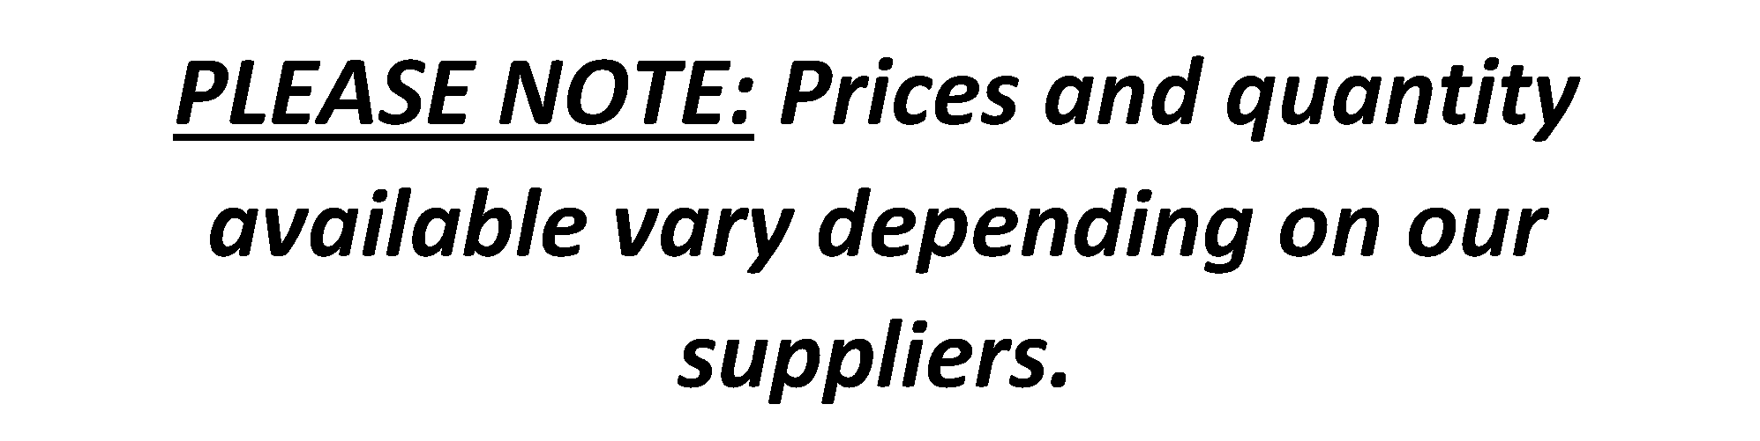PRICE LIST

**DRINKS**

Protein Drinks **(chocolate, vanilla)**........................$3.00

**(Caramel when available)**

Sparkling Ice…….……..$2.00

Chocolate Milk ….……..$2.00

IcedTea/Lemonade ……$1.50

Juice (cranberry-apple)..….……$1.50

**COOKIES & TREATS**

Nutella Snacks ………..$2.00

Crispy Apple Chips.....$1.50

Oreo Cookies (2) ........$1.50

Choc Chip Cookies…...$1.00

Sesame Snaps………….$0.50

Wagon Wheel………....$0.50

**ICE CREAM GOODIES**

Ice Cream Sandwich...$1.00

Mini Ice Cream Sandwch..$0.50

Lolly Popsicle………....$0.50

**SNACK & LUNCH ITEMS**

Lunchables……………$4.00

Beef Jerky..……..….…$3.50

Tuna/Chicken Snacks..$3.50

Bits & Bites………......$3.50

Crispers (all dressed) …$3.50

SmartFood Popcorn…$1.50

Munchies .……….….…$1.50

SunChips…….…………$1.50

Veggie Stix/Chips.….$1.50

PopCorners……………$1.00

Pringles…………………$1.00

Hot Rod……………………$1.00

Pepperoni Stick……..….$0.50

**ICE CREAM GOODIES**

Vanilla Ice Cream Sandwich $1.00

Mini Ice Cream Sand $0.50

Lolly Popcicle $0.50